**Institute of Technology Tralee**

**BSc. in Computing with Specialism (Group 5) - Year 1**

**Continuous Assessment #1**

**Date: 24/10/13**

**Time: 10a.m. – 12p.m.**

**Introduction to Programming**

**Instructions:** Attempt the following question. You should use the JCreator IDE for coding. When you are finished you must print out your code for correction.

**________________________________________________________**

**Q1.**

In its December 2010 budget, the Irish government introduced a so-called Universal Social Charge (USC) on its citizens. This **tax only applies to persons who earn more than €4,004 per year**. If the earnings of a person exceed this threshold, then the following rates apply:

|  |  |
| --- | --- |
|  | |
| **Rate of USC** | **Charged on income between** |
| 2% | €0 to €10,036 |
| 4% | €10,036.01 to €16,016 |
| 7% | above €16,016 |

So, for example, if a person has earnings of €2,000, then that person pays no USC. If a person earns €5,000 then that person must pay a USC of 2% **on all of the €5,000** i.e. €100. If a person earns €15,000 then it gets a bit more complicated, with the first €10,036 being charged at 2% and the remainder i.e. €15,000-€10,036 being charged at 4% to give a total USC of €200.72 + €198.56 = €399.28. If the earnings are above €16016 then it is even more involved, with 3 different rates in the calculation and the person having to pay a rate of 7% on a certain portion of their earnings.

Write a Java program that reads in the yearly earnings of the user. If the value entered is invalid (less than zero) then an appropriate error message should be displayed and the program should then immediately terminate. If the value entered is valid then the program should calculate the USC the user will be subjected to, based on the information above. The USC payable should then be displayed to **2 decimal places**.

For full marks here your program should, along with a logically correct solution for the problem above, include **single and multi-line comments** and **meaningful variable names**. You should also aim to use **proper indentation** in the coding of the program.

Your program should run exactly as indicated in the following sample screenshots, with all newlines, tabs etc. included (the header is tabbed out 2 tabs from the edge of the window). Also, you should use the test values indicated when testing your own program.

**Sample Screenshots**

**Run 1 – an invalid value is supplied for earnings and the program immediately quits**

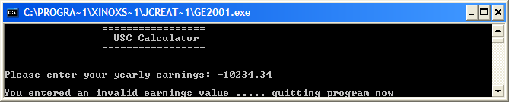

**Run 2 – an earnings value of €4000 is supplied**

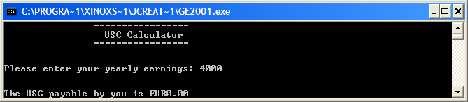

**Run 3 – an earnings value of €8056.28 is supplied**

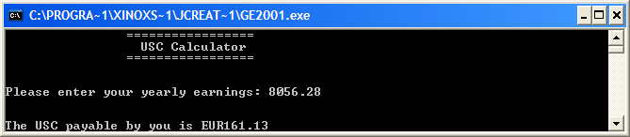

**Run 4 – an earnings value of €14657.50 is supplied**

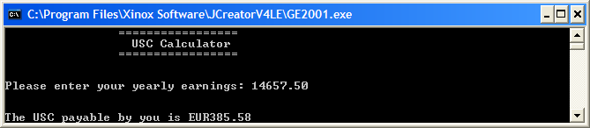

**Run 5 – an earnings value of €25657.45 is supplied**

